**Parul University**

Parul Institute of Computer Application

Basic Software Engineering – 05101253

**Semester – 3**

**Case Study Example: Surrounding Security System (SSS)**

**Practical 3.2:** To develop Use Case Diagram for SSS

**Use Case Diagram:** A use case diagram at its simplest is a representation of a user's interaction with the system that shows the relationship between the user and the different use cases in which the user is involved.

**Notation of Use Case Diagram:**

* **Actor:** An Actor is outside or external the system. Represented by the following -

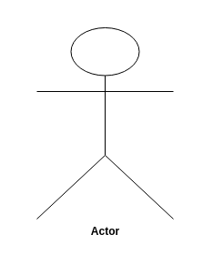

* **Use Case:** A use case is a summary of scenarios for a single task or goal. Represented by oval -
* **Relationships:** Represent communication between actor and use case. Represented by line -
* **Boundary:** A boundary rectangle is placed around the perimeter of the system to show how the actors communicate with the system.

**Use Case Diagram for SSS:** In SSS there are 2 Actors

* User
* Admin

**1. User:**

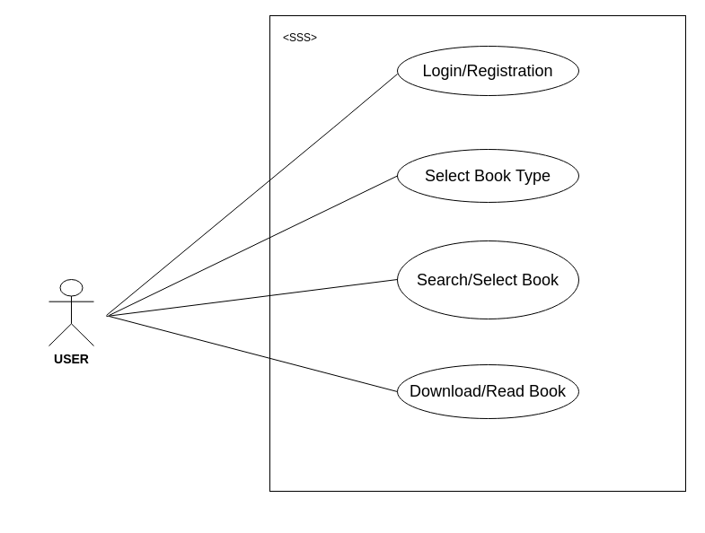

**2. Admin:**

